**LINUX**

**Topic A – Productivity & Application Software**

This task manager shows you all the running processes and their memory consumption. You can choose to end a process from this task manager application. When you have just begun with Linux, you look for a **task manager equivalent in Linux** as well. An expert Linux user prefers the command line way to find processes and memory consumption etc but you don’t have to go that way, at least not when you are just starting with Linux. All major Linux distributions depends on your Linux have a task manager equivalent. Mostly, **it is called System Monitor** but it actually distribution and the [desktop environment](https://wiki.archlinux.org/index.php/desktop_environment) it uses.

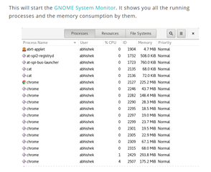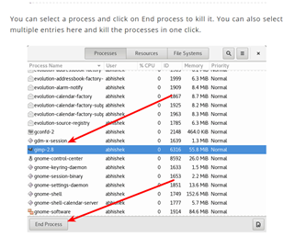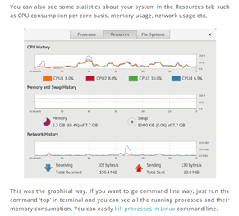

<https://itsfoss.com/task-manager-linux/>

version *1.1.0*:

* § You can now filter notes by tag in the search box, including multiple tags. For example, if you wanted to search for notes tagged ‘travel’ and ‘poetry’, you would enter ‘tag:travel tag:poetry’ in the search bar.
* § We’ve made some UI improvements to the app, including better support for running the app at smaller screen sizes and a new placeholder view that shows when there are no notes to display in the app.
* § Many performance and reliability updates.
* § A security fix related to cross-site scripting in the markdown preview.
* version *1.1.0*:
* § You can now filter notes by tag in the search box, including multiple tags. For example, if you wanted to search for notes tagged ‘travel’ and ‘poetry’, you would enter ‘tag:travel tag:poetry’ in the search bar.
* § We’ve made some UI improvements to the app, including better support for running the app at smaller screen sizes and a new placeholder view that shows when there are no notes to display in the app.
* § Many performance and reliability updates.
* § A security fix related to cross-site scripting in the markdown preview.

a bug fix release that includes:

* A fix for notes sometimes not syncing when the connection went offline.
* Links now open in an external browser instead of an internal window.
* Small design improvements.
* History: drag the History slider to view previous versions.
* Collaboration: share your note with others and allow them to edit.
* Publishing: make your note public with its own URL.
* Tags: organize your notes effectively with tags.
* Pinning: pin notes right from the note list so they’re easy to find.

<https://simplenote.com/category/linux/>

**Topic B – Entertainment & Media Software**

* Kodibuntu
* featuring a 10-foot user interface for use with televisions and remote controls. It allows users to play and view most videos, music, podcasts, and other digital media files from local and network storage media and the internet

The official Kodi version does not contain any content what so ever. This means that you should provide your own content from a local or remote storage location, DVD, Blu-Ray or any other media carrier that you own. Additionally Kodi allows you to install third-party plugins that may provide access to content that is freely available on the official content provider website. The watching or listening of illegal or pirated content which would otherwise need to be paid for is not endorsed or approved by Team Kodi.

<https://nactvbox.wordpress.com/2016/06/13/kodi-facts-what-exactly-is-kodi-and-what-does-it-do/>

* Mythbuntu

Watching what you want when you want is a luxury that’s been perpetuated by on-demand, digital delivery, and DVR. MythTV was developed to enhance the DVR experience, and Mythbuntu adds the functionality of Ubuntu. The interface is tailored for a DVR format, with options to watch live TV, manage recordings, and view a media library.

Mythbuntu is perfect for those seeking a simple yet powerful DVR management solution to integrate with a TV tuner, this is it. As someone sans-TV tuner, I tried it for local playback which did work, but if you’re like me and don’t have a tuner, you’re better off with a solution like Kodibuntu or GeeXbox

* gaming

Ubuntu’s software support doesn’t end with applications. Game developers often port their titles with Ubuntu in mind. The Steam website provides a Linux client aimed at Ubuntu. GOG.com only officially supports Ubuntu (and the Ubuntu-based Linux Mint).

These sites and the games they distribute aren’t limited to Ubuntu. You can find ways to run them on other Linux-based operating systems. Some even [make Linux gaming an easy job](https://www.makeuseof.com/tag/best-linux-gaming-operating-systems/).

[5 Best Linux Operating Systems for Gaming](https://www.makeuseof.com/tag/best-linux-gaming-operating-systems/) [**5 Best Linux Operating Systems for Gaming**](https://www.makeuseof.com/tag/best-linux-gaming-operating-systems/)Linux isn't ideal for gaming, but it's absolutely possible! Here are five Linux distributions made specifically for gaming.**[READ MORE](https://www.makeuseof.com/tag/best-linux-gaming-operating-systems/)**

But if things go wrong, the Ubuntu version is the one you where you can expect to receive help from game distributors or developers. Elsewhere, you will have to turn to the broader community and cross your fingers that fixes exist.

.

<https://www.makeuseof.com/tag/awesome-linux-media-center-distros-htpc/>

**Topic C – Programming Tools & Environment**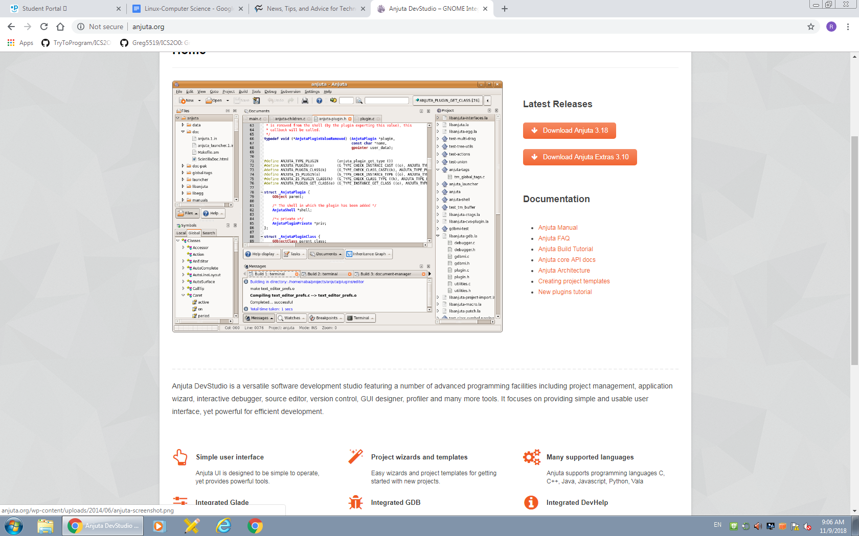

2: Anjuta

## [Anjuta](http://anjuta.sourceforge.net/) is a free, open source IDE for the C and C++ languages. It's easy to install (*urpmi anjuta* on Mandriva, for example) and offers such features as project management, application wizards, an interactive debugger, and a powerful source code editor (with source browsing, code completion, and syntax highlighting). The Anjuta team developed this powerful IDE to be easy to use and still meet all of your C and C++ programming needs.

Anjuta has a flexible and powerful user interface that allows you to drag and drop the tools in the layout to arrange the GUI nearly any way you like. And each user-configured layout is persistent for the project (so you can have different layouts for every project you have going). Anjuta also enjoys a powerful plug-in system that allows you to decide which plug-ins are active and which are not for each project. And like all open source projects, you can develop your own plug-ins for Anjuta. One of the most powerful tools in the Anjuta application is the project manager. This tool can open nearly any automake/autoconf-based project. This project manager doesn't add any Anjuta-based information to the project, so your project can be maintained and developed outside of Anjuta as well.

## 3: Glade

[Glade](http://glade.gnome.org/) is a RAD (rapid application development) tool used to create GTK+ toolkit and for the GNOME desktop. Its interface is similar to that of The GIMP and can be customized and even embedded into Anjuta. Glade includes a number of interface building blocks, such as text boxes, dialog labels, numeric entries, check boxes, and menus, to make the development of interfaces quicker. Interface designs are stored in XML format, which allows these designs to be easily interfaced with external tools. Installing Glade is simple. For instance, when in Fedora, you can issue the command *yum install glade3.* Glade does not have as powerful a project manager as Anjuta, but you can create, edit, and save projects with Glade.

## **4: GCC**

## [GCC](http://gcc.gnu.org/) is a GNU compiler that works for C, C++, Objective C, FORTRAN, Java, and Ada. It's a command-line tool but is very powerful. Many IDEs have tools that are merely front ends for GCC. GCC is actually a set of tools. The most used are the compilers for C and C++ code. How does one tool compile for different languages? Simple: For C, you invoke the "gcc" command and for C++, you invoke the "g++" command. Two compilers in the same toolkit. And g++ is a compiler, not just a preprocessor. It will build object code from source code without using an intermediary to first build C code from C++ source. This creates better object code and gives you better debugging information.

<https://www.techrepublic.com/blog/10-things/10-linux-and-open-source-developer-tools-you-should-not-overlook/>

**Topic D – System Tools**

* The Bootloader: The software that manages the boot process of your computer. For most users, this will simply be a splash screen that pops up and eventually goes away to boot into the operating system.
* The kernel: This is the one piece of the whole that is actually called “Linux”. The kernel is the core of the system and manages the CPU, memory, and peripheral devices. The kernel is the “lowest” level of the OS.
* Daemons: These are background services (printing, sound, scheduling, etc) that either start up during boot, or after you log into the desktop.
* The Shell: You’ve probably heard mention of the Linux command line. This is the shell – a command process that allows you to control the computer via commands typed into a text interface. This is what, at one time, scared people away from Linux the most (assuming they had to learn a seemingly archaic command line structure to make Linux work). This is no longer the case. With modern desktop Linux, there is no need to ever touch the command line.
* Graphical Server: This is the sub-system that displays the graphics on your monitor. It is commonly referred to as the X server or just “X”.

<https://www.linux.com/what-is-linux>

**Topic E – Software Security & Updates**

1. [ClamAV](http://www.clamav.net/lang/en/)

My favorite antivirus software for Linux is Sourcefire's ClamAV, a free, [open source](http://www.pcworld.com/businesscenter/article/209891/10_reasons_open_source_is_good_for_business.html) package designed to detect Trojans, viruses, malware and other malicious threats. Included in the software, which now comes preinstalled in several [Linux distributions](http://www.pcworld.com/businesscenter/article/204767/a_guide_to_todays_top_10_linux_distributions.html), are a multithreaded scanning daemon, command line utilities for on-demand file scanning, and an intelligent tool for automatic signature updates. Of particular note for past or current Windows users is that the core ClamAV library is also used in [Immunet 3.0](http://www.immunet.com/), a sister solution for Microsoft's operating system.

2. [Snort](http://www.snort.org/)

Also offered by Sourcefire is Snort, an open source network intrusion prevention and detection system that combines the benefits of signature, protocol and anomaly-based inspection. With millions of downloads and more than 300,000 registered users to its credit, Snort is the most widely deployed such technology worldwide, Sourcefire says.

**3. [Wireshark](http://www.wireshark.org/)**

Wireshark is a network protocol analyzer that lets you capture and interactively browse the traffic running on a computer network. The software runs not just on Linux but on Windows, OS X, Solaris, FreeBSD and NetBSD, as well. Captured network data can be browsed via GUI or via the TTY-mode TShark utility.

<https://www.pcworld.com/article/224955/7_free_security_tools_for_linux.html>

Ubuntu Linux has become one of the most popular of all the Linux distributions. And through the process of updating a system, you should be able to tell exactly why this is the case. Ubuntu is very user friendly. Ubuntu uses two different tools for system update:

* apt-get: Command line tool.
* Update Manager: GUI tool.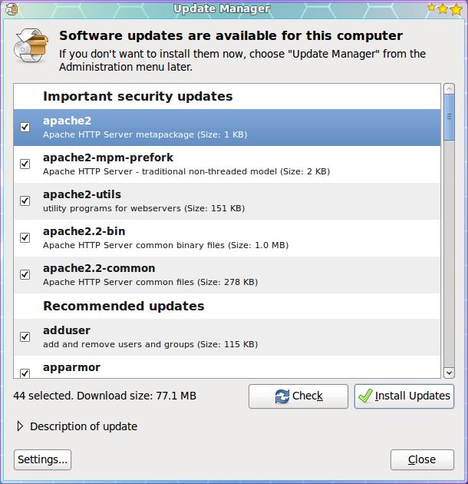

The Update Manger is a nearly 100% automatic tool. With this tool you will not have to routinely check to see if there are updates available. Instead you will know updates are available because the Update Manager will open on your desktop (see Figure 1) as soon as the updates depending upon their type:

* Security updates: Daily
* Non-security updates: Weekly

If you want to manually check for updates, you can do this by clicking the Administration sub-menu of the System menu and then selecting the Update Manager entry. When the Update Manager opens click the Check button to see if there are updates available.

Figure 1 shows a listing of updates for a Ubuntu 9.10 installation. As you can see there are both *Important Security Updates* as well as *Recommended Update*. If you want to get information about a particular update you can select the update and then click on the *Description of update* dropdown.

In order to update the packages follow these steps:

1. Check the updates you want to install. By default all updates are selected.
2. Click the Install Updates button.
3. Enter your user (sudo) password.
4. Click OK.

The updates will proceed and you can continue on with¬† your work. Now some updates may require either you to log out of your desktop and log back in, or to reboot the machine. There are is a new tool in development ([Ksplice](http://www.ksplice.com/))¬† that allow even the update of a kernel to not require a reboot.

Once all of the updates are complete the Update Manage main window will return reporting that *Your system is up to date*.

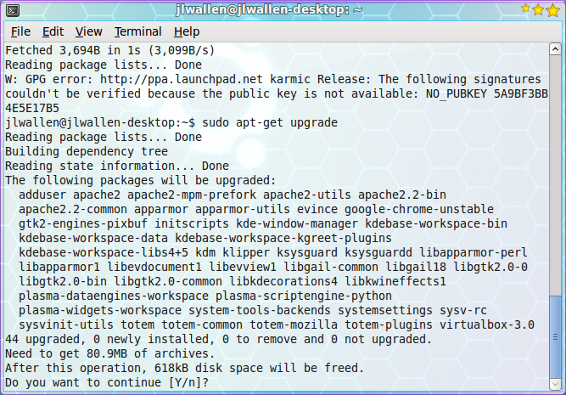Now let's take a look at the command line tools for updating your system. The Ubuntu package management system is called *apt*. Apt is a very powerful tool that can completely manage your systems packages via command line. Using the command line tool has one drawback - in order to check to see if you have updates, you have to run it manually. Let's take a look at how to update your system with the help of Apt. Follow these steps:

1. Open up a terminal window.
2. Issue the command *sudo apt-get upgrade*.
3. Enter your user's password.
4. Look over the list of available updates (see Figure 2) and decide if you want to go through with the entire upgrade.
5. To accept all updates click the 'y' key (no quotes) and hit Enter.
6. Watch as the update happens.

That's it. Your system is now up to date.

<https://www.linux.com/learn/linux-101-updating-your-system>

**Topic F – File System & User Accounts**

**Topic G – Special Features of your OS**

**Topic H – Limitations of your OS**